COUNCIL POLICY

SNOW AND ICE REMOVAL POLICY
Policy #: R/S-002-2025
Section: Roads & Streets
Rescind Policy #: R/S-002
Legislative Reference: Municipal Government Act & Snow Removal Guidelines for the Province of Alberta

- PURPOSE
  - To provide Public Works guidelines for reducing or eliminating snow and ice hazards and to minimize the inconvenience of winter conditions for motorists and pedestrians, to the greatest degree possible, within available resources of the Town of Smoky Lake.

• Add the back alleyway from 53 Avenue East to West Railway Drive as a Priority 3 route; and
• Include

- DEFINITIONS
2.1 In this Policy:
a) “CAO” shall mean the Chief Administrative Officer of the Town of Smoky Lake;
b) “Downtown District" shall mean White Earth Street from 50th Street to McDougall Drive and Wheatland Avenue from 50th Street to West Railway Drive;
c) “Town” shall mean the Municipal Corporation of the Town of Smoky Lake;

- POLICY STATEMENT
3.1 Snow and ice removal from public roadways and walkways and areas for which the Town has assumed responsibility will be conducted based on the following order of priority as shown in Schedule “A”:
a) Priority 1 – Main Roads and Downtown District
b) Priority 2 – Secondary Roads
c) Priority 3 – Parking Lots and Trails
d) Priority 4 – Residential Streets and Back Lanes
3.2 Snow and ice control will commence when accumulation of five (5) cm for sidewalks, seven and a half (7.5) cm of snow in the downtown district, ten (10) cm of snow occurs on the main roads and twenty (20) cm in the residential district.

3.3 Priority 1 shall be cleared within twenty-four (24) hours of snowfall accumulations as per section 3, subsection 2.

3.4. Where labor and equipment is available, sections of the priority lists may be carried out
simultaneously.
3.5. Snow and ice that has accumulated on the streets shall not be placed onto any developed or undeveloped lots or sidewalks. Snow and ice may be windrowed on the street, medians or boulevards and may be windrowed and placed in ditches.

3.6 Priority 3 - Back alleyway from 53 Avenue East to West Railway Drive.

POLICY DETAILS
  - Snow and ice removal will generally take priority over all but emergency or mandatory daily procedures.
  - Wherever feasible, snow and ice will be removed in the downtown business section outside of regular business hours.

  - The Town will make reasonable efforts to keep the back lanes in a passable condition.

  - Snow will be ploughed onto boulevards or windrowed when necessary. Although Public Works will make an effort to remove windrows from residential driveways and back-alley access, it will be completed as time permits, following priority snow clearing.

  - If a residence has both driveway and sidewalk entrances, only the driveway will be opened by the Town.

  - The Town will not remove snow and ice from the front of residents’ properties for vehicle parking.

  - Clear access to hydrants will be maintained after the completion of other snow and ice removal work.

  - To ensure adequate line of sight, snow and ice shall not be piled higher than one (1) meter within three (3) meters of any intersection.

  - Snow shall not be piled within one (1) meter of any traffic control sign.

4.10 The CAO may hire contractors for snow removal when needed.

4.10 CAO may suspend snow removal operations due to extreme weather conditions for the safety of Town employees.

4.11 Provisions granting the CAO and Public Works Manager the discretion to conduct sanding and salting operations as required.

- RESIDENTIAL AND BUSINESS RESPONSIBILITIES
5.1 Residents and businesses are responsible for complying with the Community Standards Bylaw.
6. SNOW AND ICE STORAGE PROVISIONS
  - Residential areas:
a) Where there are residents located on both sides of the street, snow and ice will be plowed to the east or south side when the season begins in an even-numbered year and to the west or north side when the season begins in an odd-numbered year;

b) Where the number of residents on one side of the road outnumbers those on the other by a ratio of 2:1, snow and ice will always be piled on the side of the road with fewer residents.

  - The following will be designated snow collection and storage areas:
- In the northeast corner of the Curling Rink lot where Wild Rose Avenue intersects with West Railway Drive.
- South and north of the Public Works Shop at 246 West Railway Drive in such a way as not to affect access to the South Side Shop or the Pumpkin Park parking lot.

- East of the Museum between the walking trail and Highway 28.

  - Snow and ice shall be collected and stored only in designated collection and storage areas. Additional storage sites may be approved by the CAO as needed in accordance with the “Snow Disposal Guidelines for the Province of Alberta” as published by the Province of Alberta.

  - Collection and storage areas will be cleaned up (garbage left from the melting mounds) within two (2) weeks of the last of the melt, as determined by the Town.

  - Private Contractors and residents will enter into an agreement with the Town to store snow at an approved location within the Town Corporate Limits, or any Town-owned property. A copy of each such agreement will be maintained at the Town office and will indicate the designated storage area(s) to be used and conditions for spring clean up of the area(s).

7. LIMITATIONS
7.1 The timeframes and requirements in this policy are goals that the Town will seek to achieve whenever possible. It is understood that certain weather events, emergencies, or other urgent needs may strain the Town’s resources and render it unable to reasonably achieve some or all of these targets. However, the Town will make reasonable efforts to comply with these requirements in accordance with the priorities set out in this Policy.

 | date | Resolution Number
Approved | November 27, 2015 | 611/15
Amended | February 5, 2019 | 65-19
Amended | September 25, 2023 | 539-2023
Amended | December 2, 2025 | 921-2025
Amended

________________________ ___________________________
Marianne Prockiw-Zarusky Molly Fyten
Mayor Chief Administrative Officer

SCHEDULE “A”
SNOW AND ICE REMOVAL POLICY

1. PRIORITIES:
- Main Roads and Downtown District – Priority 1:
Will be cleared within twenty-four (24) hours of snowfall accumulation.
- Town main entrance roads (44 Avenue and West Railway Drive);
- Hospital road (55th Avenue);
- East end of McDougall Drive crossing Iron Horse Trail (West Railway Drive to 48th Avenue/East Railway Drive intersection);
- Downtown District (White Earth Street from 50th Street to McDougall Drive and Wheatland Avenue from 50th Street to West Railway Drive);
- Highway commercial access (53rd Street from 44th Avenue to 45th Avenue, 45th to 56th Street Harvest Gold Drive, Harvest Gold Drive to County Shop including Highway 28 access) and (56th Street from 44th Avenue to 42nd Avenue including Highway 28 access);
- East Railway Drive.

- Secondary Roads – Priority 2:
- McDougall Drive;
- 52nd Avenue Loop (52nd Avenue from West Railway Drive to 48th Street, 48th to 53rd Avenue, 53rd to 46th street, 46th to McDougall Drive);
- 54th Avenue route (54th Avenue from 50th Street to 46th street, 46th south to 53rd Avenue, 53rd to 43rd street, 43rd to 55th Avenue) and (46th Street north from 54th Avenue to 55th Avenue);
- Willow Creek Street;
- 30th Avenue loop (30th Avenue from Highway 855 looping back to 855 by 50th Street) and (30th Avenue to and including 51st Street to the South Public Works Shop);
- Toporoutz Road (between the Iron Horse Trail and Highway 855).

- Parking Lots and Trails – Priority 3:
- Public Works, Fire Hall;
- Pumpkin Park parking lot;
- Curling Rink parking lot;
- Town Office parking lot;
- Walking Trail loop;
- Sidewalks;
- Back Alleyway from 53 Ave to West Railway Dr.

- Residential Streets and Back Lanes – Priority 4:
- Lanes in the downtown core;
- Residential Streets beginning from the west;
- Residential Avenues beginning from the south;
- Other alleys as required or time permitting.

SIDEWALK PRIORITY
Snow clearing on sidewalks may commence after a storm event or during routine maintenance when snowfall accumulations are greater than five (5) cm.
- Pink (Downtown District)
- Blue (School Route) will start by 7:30 am on School Days
- All other sidewalks will be done after Downtown Core and School Route

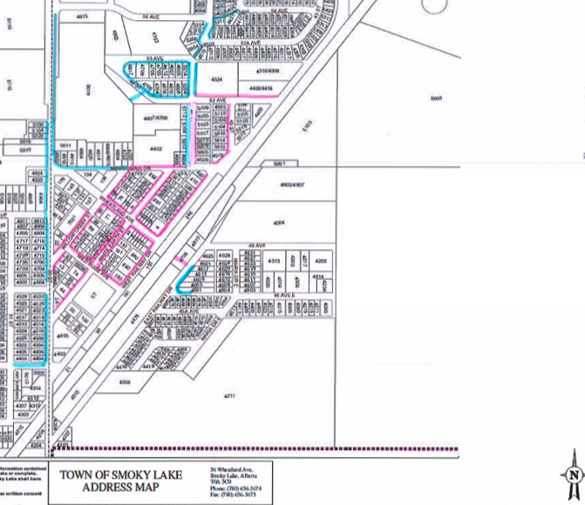

ROAD PRIORITY
- Pink – Priority 1
- Yellow – Early morning after snowfall
- Blue – After priority roads 1 and 2
- All other streets will be cleared after a major snow fall event.

